

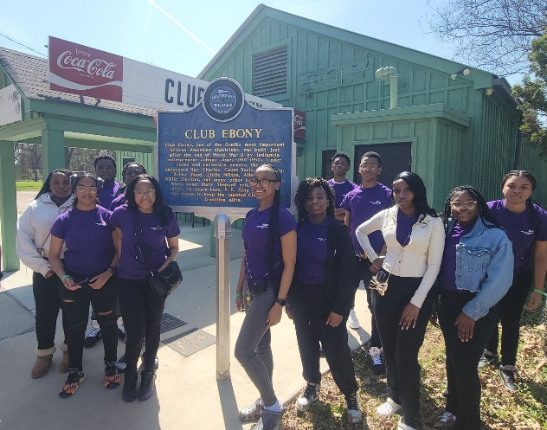
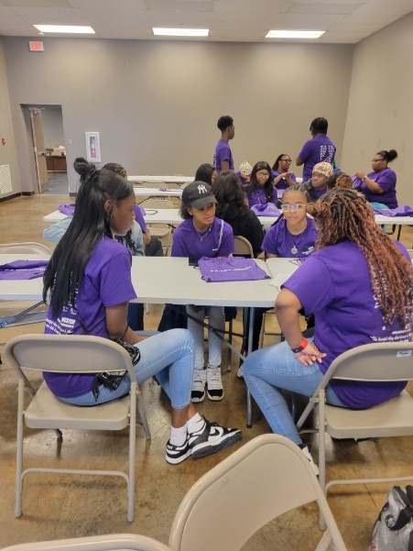
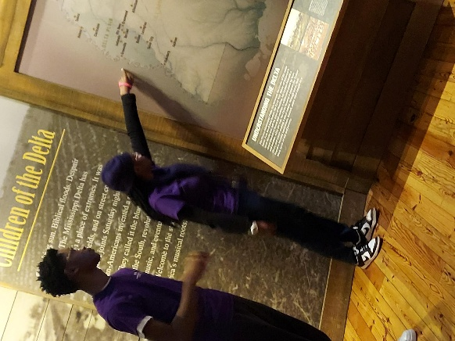

BB’s Bridge Building Ambassadors

APPLICATION
PACKET
2025-2026
BB’s Bridge
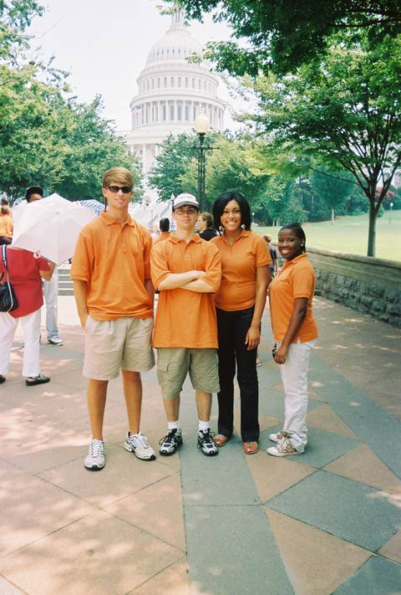
Building Ambassadors

BB’s Bridge Building Ambassadors:
- Study about the museum and the life of B. B. King in Saturday classes
- Learn to serve as a tour guide for the Museum’s Permanent Exhibition
- Earn a minimum of 40 hours of community service hours
- Lead tours and discussions on the lessons of the Delta
- Become part of a national youth leadership network with other peers from around the country
- Become youth leaders by participating in leadership and team-building activities
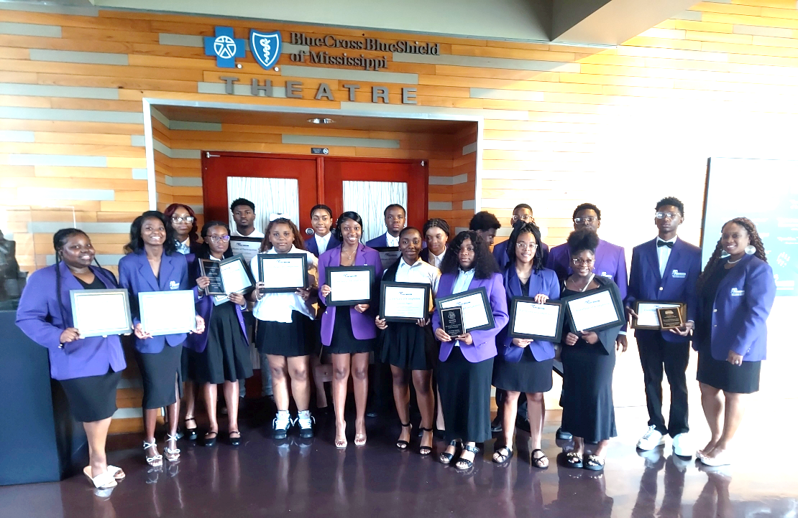

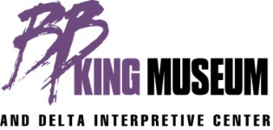
400 Second St. / Indianola, Mississippi 38751 662-887-9539 / info@bbkingmuseum.org
Youth Leadership Program: Delta Education for the Community

BB’s Bridge Building Ambassadors is dedicated to celebrating the life and music of B. B. King as his expressed wish that education and community outreach be at the heart of our mission. We honor him and his legacy by providing this educational program designed to offer young people the kind of hope and opportunity that were not available to Riley B. King in the Delta of his youth. The museum’s exhibits and educational programs; the stories of the Delta - its history, music, social mores, race relations, literature and legends, adversities and successes, will serve to build bridges in the community while preserving the rich cultural and musical heritage of the Mississippi Delta; and, to reach those individuals and communities that might not otherwise have access to this education, the Museum will develop a number of programs—one of which we hope BB’s Bridge Building Ambassadors will be our most successful.

BB’s Bridge Building Ambassadors
Goal:
Launched in 2011, using the Museum’s mission, exhibits and educational programs, the stories of the Delta - its history, music, social mores, race relations, literature and legends, adversities and successes, BB’s Bridge Building Ambassadors will provide Delta area youth the opportunity to become actively involved with the Museum. Through this program, the Museum will develop long-term partnerships with the local middle and high schools, enabling students to participate in a series of training experiences and internship opportunities that will help them develop into lifelong learners, productive citizens, and community leaders.

Objectives:
- To build students’ understanding of personal leadership concepts and the importance of developing leadership skills;
- to build students’ knowledge base of the BBKM’s permanent exhibits, the history of the Delta, Blues and Civil Rights; the role of cotton and race in the Delta;
- to promote student confidence, self-esteem, character, and community involvement through active participation;
- to build students’ knowledge base of financial planning including creating a budget, saving money, planning for college, retirement, taxes, insurance and much more; and
- to involve youth leaders in project planning and implementation.
Expectations:
Upon acceptance as one of BB’s Bridge Building Ambassadors, students are expected to attend Saturday workshops on designated Saturdays of each month from 9:00 am until 12:00 noon. The workshops will build students’ knowledge base of the BBKM’s permanent galleries, artifacts, exhibitions, and the history of the Delta and its culture. Also, students will be expected to participate in BBKM’s public programs, community service opportunities, and field trips.

Eligibility
9th through 12th-grade students from the Sunflower County public and private schools are eligible to apply.

BB’s Bridge Building Ambassadors is based upon two core principles:

THE HISTORY AND LESSONS OF THE DELTA ARE RELEVANT TO TODAY ’S WORLD. By encouraging young people to examine the implications of the injustices of the Jim Crow laws, as experienced by Riley B. King, the program will improve their ability to analyze current events that affect their neighborhoods, communities, and the larger world. Students also acquire a concrete basis for exploring the nature of indifference and racism, as well as their roles as citizens of a democracy.

STUDENTS SHOULD BE ACTIVELY ENGAGED IN THEIR OWN EDUCATION.
The program creates a learning environment in which the insights and opinions of young people are taken seriously. After completing a series of intensive classes, students lead their parents, peers, and other members of their communities on tours of the Museum. The program and the principles upon which it is based will serve as the model for other partnerships the Museum will develop with new audiences.

“The beautiful thing about learning is that no one can take it away from you.”
─Riley “BB” King

Youth Leadership Program
Delta Education for the Community

2025-2026 Application
Timeline:
- September 19, 2025: Applications Due (priority deadline)
- September 22 - 24, 2025: Applications reviewed
- September 26, 2025: Applicants will be notified regarding selection decisions

In addition to this form, all applications must include an essay, a photo, and a letter of recommendation.
Student Information
Name (first) _________________________ (middle)________________ (last) ____________________
Date of Birth _______________________________________ M/F________________
Address__________________________________________ City____________________ Zip_________
Home phone ________________________________________Cell phone_________________________
E-mail address ________________________________________________________________________
Name of parents/guardians ______________________________________________________________
Parents’ home phone ___________________Cell phone ________________Work phone _____________
Allergies: ____________________________________________________________________________
Education Information
School _________________________________________________________ Grade Level ___________
Homeroom Teacher ___________________________________________________________________
MVSU Upward Bound Participant: Yes ________________ No_________________
Extra-Curricular Activities/Sports _________________________________________________________

T-shirt Size _______________________________ Blazer (jacket) size __________________________
If accepted, I agree to fully participate and commit to BB’s Bridge Building Ambassadors Youth Leadership Program: Delta Education for the Community.
Student’s Signature___________________________________________ Date ________________
Parent/Guardian’s Signature____________________________________ Date _________________
Date Received __________________ Received by ___________________ Status ___ Approved ___ Denied
Comments:_______________________________________________________________________________________________________________________________________________________________________________________________________________

*********************************** For Office Use Only********************************

COVID-19 WAIVER
Due to the COVID-19 pandemic, the B.B. King Museum and Delta Interpretive Center has been exploring different and reasonable ways to provide services to all ambassadors. The B.B. King Museum and Delta Interpretive Center has worked with state and local agencies, including our local health department, to draft and implement guidelines moving forward regarding cleaning, screening, social distancing, etc. Though the B.B. King Museum and Delta Interpretive Center will work hard to implement and abide by those guidelines, neither the guidelines themselves nor even guidance from the Centers for Disease Control and Prevention (“CDC”) would allow the B.B. King Museum and Delta Interpretive Center to guarantee an environment that is entirely free of COVID-19 related risks.
By allowing your child to participate in field trips, however, you acknowledge and understand that your child’s attendance will require him/her to interact physically with outside people. As such, despite reasonable mitigation efforts on behalf of the B.B. King Museum and Delta Interpretive Center, physical interaction with others may pose some unavoidable risks due to the COVID-19 pandemic. With that, you further acknowledge and agree to the following:
1. Waiver and Release. You hereby release and forever discharge and hold harmless the B.B. King Museum and Delta Interpretive Center and employees from any and all liability, claims and demands of whatever kind or nature, either in law or in equity, which arise or may hereafter arise from your child’s return to building and/or participation in activities associated with the B.B. King Museum and Delta Interpretive Center. You understand that this release discharges the B.B. King Museum and Delta Interpretive Center from any liability or claim that you may have against the B.B. King Museum and Delta Interpretive Center with respect to COVID-19.
2. Assumption of Risk. You further understand that your child’s return and/or participation may expose him/her and others to unavoidable COVID-19 community spread. As such, you hereby expressly and specifically assume the risk of injury or other harm, and also expressly release the B.B. King Museum and Delta Interpretive Center and employees from all liability for illness resulting from COVID-19.
BY SIGNING BELOW, YOU ACKNOWLEDGE HAVING READ AND UNDERSTOOD ALL OF THE ABOVE-TERMS AND CONDITIONS.
______________________________ ______________________________
Child’s Printed Full Name* Child’s Signed Full Name*

______________________________ ______________________________
Parent’s Printed Full Name* Parent’s Signed Full Name*

Release for Use of Photographs, Videotape and/or Audiotape Recording(s)
I, __________________________________________, acknowledge and agree to the following:
- My image, actions, and words will be photographed and/or recorded on videotape and/or audio-taped by the B. B. King Museum as a BB’s Bridge Building Ambassador.

- The B. B. King Museum desires to use and reproduce this media, in whole or in part, to further its overall mission, including for educational, scholarly, development, and fundraising purposes.

- My consent and permission is required to allow the B. B. King Museum to use my image, actions, and words, photographed, videotaped and/or audio-taped as a BB’s Bridge Building Ambassador.

- I therefore grant permission to the B. B. King Museum to use and reproduce the photographs, videotape and/or audio recording made during this event, including my image, actions, and words as recorded thereon, in any and all media now known or yet to be developed in the future, for all purposes relating to the Museum’s overall mission, including for educational, scholarly, development, and fundraising purposes. This grant of permission extends throughout the world in perpetuity.

______________________________________________ ____________________________
Parent/Guardian’s Signature Date

_______________________________________________ ______________________________
Child’s Signature Date

______________________________________________________________________________
Physical/Mailing Address City State Zip Code

ESSAY REQUIREMENTS
Please TYPE a 1 page double-spaced essay covering each of the following using size 12. Times New Romans font.
- How did you learn of BB’s Bridge Building Ambassadors Youth Leadership Program?
- Briefly describe yourself -interests, hobbies, skills, and personal philosophy. Tell us about any programs you have participated in and any organizations in which you have volunteered.
- What are your plans after you graduate from high school? If college, what are your prospective schools and majors? If work, in what fields are you interested?
- Are you interested in learning history? Why or why not?
- What leader do you admire most? What in your opinion makes this person a great leader?
- Do you think service/volunteerism is important? Why or why not?
- What do you hope to gain from BB’s Bridge Building Ambassadors Youth Leadership Program?
Check-Off List

____ Completed application form
____ Typed essay
____ Letter of recommendation from teacher or counselor (sealed)
____ Photograph (no selfies or filters please)
____ COVID-19 Waiver
____ Survey
____ ALL forms completed and signed by the parent/guardian and student

Please mail or drop off the application packet to the B.B. King Museum and Delta Interpretive Center. The deadline is 5:00 p.m. Friday, September 19, 2025. If you have any questions, please call Khalilah Ransom, Ambassador Coordinator, at the number below.

B. B. King Museum and Delta Interpretative Center
BB’s Bridge Building Ambassadors Youth Leadership Program
400 Second Street
Indianola, Mississippi 38751
662-887-9539

BB’s Bridge Building Ambassadors Youth Leadership Program: Education for the Delta

Background Information Survey

Your responses to this survey are confidential. Information in this section will only be used for outcome documentation. Individual results will never be reported; only group responses will be used in ways that specific responses will not be identifiable.
Background Information
1. How comfortable are you | Very Comfortable | Somewhat Comfortable | Somewhat Uncomfortable | Very Uncomfortable | Not Sure
Interacting with someone of a different race in a public setting? | O | O | O | O | O
Interacting with someone of a different race in a private setting? | O | O | O | O | O
Being friends with someone of a different race? | O | O | O | O | O
Attending school with someone of a different race? | O | O | O | O | O
Visiting in the home with someone of a different race? | O | O | O | O | O
2. Please describe each of the following: | All black people | Mostly black people | Half people black/Half white people | Mostly white people | All white people
The neighborhood where I live | O | O | O | O | O
3. Personal Perception of School Climate? | Very Welcoming | Somewhat Welcoming | Somewhat Unwelcoming | Very Unwelcoming | Not Sure
To what extent are most students at my school welcoming to people of color? | O | O | O | O | O
4. Please answer the following to the best of your ability. | Strongly Agree | Agree | Disagree | Strongly Disagree | Not Sure
Most students at my school are welcoming to students of a different color. | O | O | O | O | O
Teachers are sensitive to barriers faced by students of a different color. | O | O | O | O | O
My school should recruit more students of color. | O | O | O | O | O
My school provides adequate services to promote the success of students of different races. | O | O | O | O | O
My school is genuinely committed to improving relations between students of different races | O | O | O | O | O
5. Please answer the following to the best of your ability. | Strongly Agree | Agree | Disagree | Strongly Disagree | Not Sure
I feel comfortable openly expressing my dislike of racist jokes or statements made at my school | O | O | O | O | O
If I were to experience racial harassment or discrimination at my school, I would feel comfortable reporting it to a faculty member, staff member, or administrator. | O | O | O | O | O
If I were to witness racial harassment or discrimination at my school, I would feel comfortable reporting it to a faculty, staff, or administrator. | O | O | O | O | O
Some administrators discriminate against different races at my school. | O | O | O | O | O
Some faculty discriminate against different races at my school. | O | O | O | O | O
Some staff discriminate against different races at my school. | O | O | O | O | O
Some students discriminate against different races at my school. | O | O | O | O | O
Racism is a problem at my school. | O | O | O | O | O

6. I have heard or witnessed the following at my school | Witnessed | Heard about | Both witnessed and heard about | Never witnessed nor heard about
A student embarrassing, patronizing or treating someone negatively because of his/her race. | O | O | O | O
A teacher or faculty member embarrassing, patronizing or treating someone negatively  because of his/her race. | O | O | O | O
A student leaving your school because of racial harassment or an unwelcoming environment. | O | O | O | O
Racist jokes, cartoons, graffiti, or flyers. | O | O | O | O

